**Ansible Configuration Management tool**

[**Ansible**](https://www.edureka.co/blog/what-is-ansible/) is an open source [Continuous Deployment](https://www.edureka.co/blog/continuous-deployment/), Configuration Management, & Orchestration. This tool aims to provide large productivity gains to a wide variety of automation challenges and is powerful enough to automate complex multi-tier IT application environments.

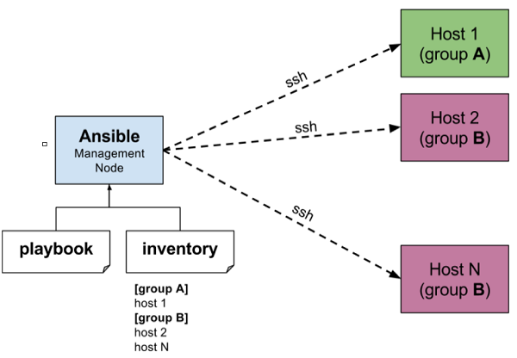

[](https://bit.ly/2qDmieD)

**SSH Key Generation**

Ansible uses SSH to communicate between the nodes.

To set up an SSH connection, follow the steps mentioned below:

* Setting Up SSH Command
* Generating SSH Key
* Copy the SSH Key on the Hosts
* Check the SSH Connection

#Setting Up SSH Command

$ sudo yum install openssh-server

#Generating SSH Key

$ ssh-keygen

#give permission to known_hosts file

$ sudo chmod 777 ~/.ssh/known_hosts

#Copy the SSH Key on the Hosts

$ ssh-copy-id hostname

#Check the SSH Connection

$ ssh <nodeName>

**Install Ansible**

To [install Ansible](https://www.edureka.co/blog/install-ansible/) in Debian based Linux, you can follow the following steps:

* Add the Ansible repository to your system, before installing Ansible
* Then run the update command before installing, to update the existing packages
* After that install the Ansible package

Using yum installation

$ wget http://dl.fedoraproject.org/pub/epel/epel-release-latest-7.noarch.rpm

$ sudo rpm -ivh epel-release-latest-7.noarch.rpm

$ sudo yum --enablerepo=epel install ansible

$ ansible --version

#Add Ansible repository using apt-get

$ sudo apt-add-repository ppa:ansible/ansible

#Run the update command

$ sudo apt-get update

#Install Ansible package

$ sudo apt-get install ansible

#Check Ansible Version

$ ansible –version

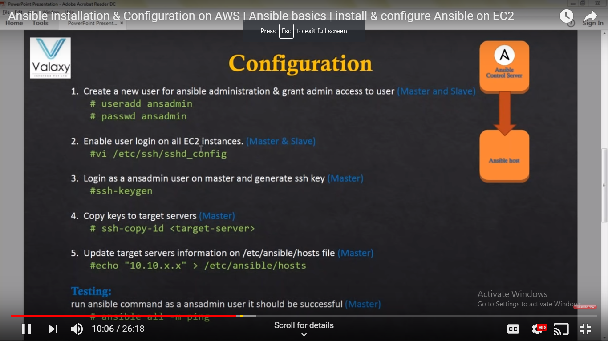

**User setup in control and agent server**

**Login to control server as root user**

$ sudo su

$ useradd ansadmin

$ passwd ansadmin

Enter the password

$ visudo

Add this below line password section

ansadmin ALL=(ALL) NOPASSWD: ALL

vi /etc/ssh/sshd_config

change the below line from no to yes

passwordauthonit yes

service sshd restart

**Login to agent server as root user**

Sudo su

Useradd ansadmin

Passwd ansadmin

Enter the password

Add this below line password section

ansadmin ALL=(ALL) NOPASSWD: ALL

vi /etc/ssh/sshd_config

change the below line from no to yes

passwordauthonit yes

service sshd restart

**Inventory Files & Hosts Patterns**

The inventory file of Ansible lists all the platforms you want to automate across. Ansible at a single instance can work on multiple hosts in the infrastructure. It is also possible to have multiple inventory files at the same time.

* The host inventory file can contain hostnames either individually or in groups
* Host Groups can be created by giving a group name within square brackets
* Group members can then be listed under, till there is a line break

**Set & Check Hosts Connection**

Follow the below steps to set hosts and then check their connection.

#Set up hosts by editing the hosts' file in the Ansible directory

$ sudo vi /etc/ansible/hosts

#To check the connection to hosts

#Change your directory to /etc/Ansible

$ cd /etc/ansible

#Ansible’s ping module allows you to check whether Ansible is connecting to hosts

$  ansible –m ping <hosts>

#To check on servers individually

$ ansible -m ping server name

#To check a particular server group

$ ansible -m ping servergroupname

**Ansible Host Patterns**

Refer to the following table to know the Ansible Host Patterns, as described in playbooks.

|  |  |
| --- | --- |
| **Ansible Host Patterns** | |
| all | All hosts in inventory |
| * | All hosts in inventory |
| ungrouped | All hosts in inventory not appearing within a group |
| 10.0.0.* | All hosts with an IP starting 10.0.0.* |
| webservers | The group webservers |
| webservers:!moscow | Only hosts in webservers, not also in group moscow |
| webservers:&moscow | Only hosts in the group’s webservers and moscow |

**Example Inventory File**

Below is an example inventory file, which you can refer to understand the various parameters.

#Default location for host file

$ /etc/ansible/hosts

#To define location for inventory, in CLI

-i<path>

#example host file

ungrouped.example.com  #An ungrouped host

[webservers]    #a group called webservers

beta.example.com ansible_host = 10.0.0.5          #ssh to 10.0.0.5

github.example.com ansible_ssh_user = abc        #ssh as user abc

[clouds]

cloud.example.com fileuser = alice          #fileuser is a host variable

[moscow]

beta.example.com                  #host (DNS will resolve)

telecom.example.com            #host(DNS will resolve)

[dev1:children]                        #dev1 is a group containing

webservers                                #all hosts in group webservers

clouds                                      #all hosts in group clouds

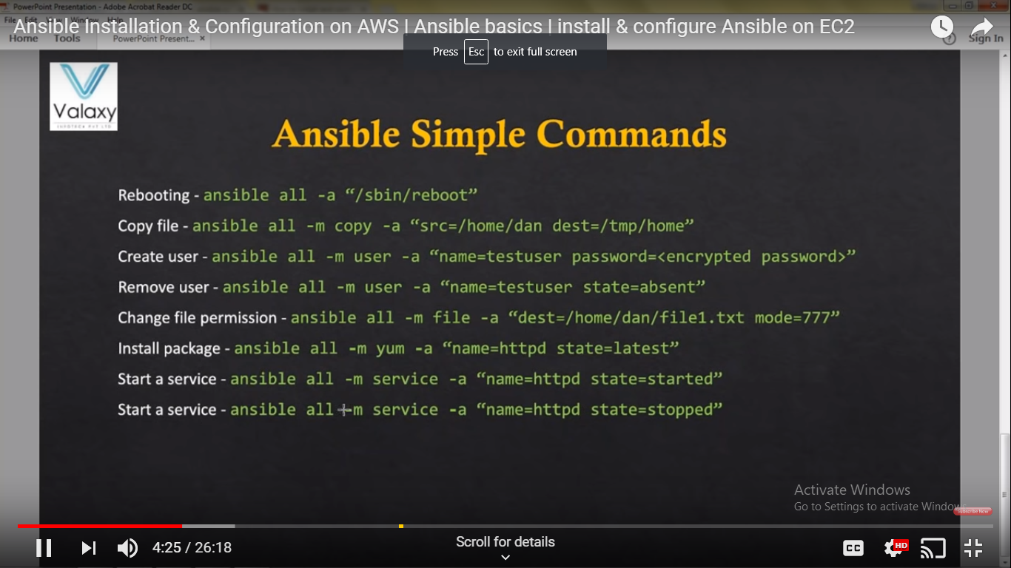

Create some files in ansadmin dir

Vi demo.txt

Add some content to demo.txt file

Using copy module

ansible all –m copy –a “src=/home/ansadmin/demo.txt dest=/home/ansadmin/”

using yum module

ansible –s all –m yum –a “name=httpd state=latest”

once installed check in the client machine

service httpd status

if its running then you would receive info of httpd

go to slave sever and start the httpd service

ansible –s all –m service –a “name=httpd state=started”

**Ad-Hoc Commands**

Ad-Hoc commands are quick commands which are used to perform the actions, that won’t be saved for later.

Some of the tasks that you can perform using Adhoc commands are as follows:

* Parallelism and Shell Commands
* File Transfer
* Managing Packages
* Deploying From Source Control
* Managing Services

I am going to explain all these tasks, with a basic example.

**Basic Example:**To reboot all the web servers present in Europe, 20 at a time.

**Parallelism & Shell Commands**

In this section, I am going to tell you the commands, for parallelism and shell.

#To set up SSH agent

$ ssh-agent bash

$ ssh-add ~/.ssh/id_rsa

#To use SSH with a password instead of keys, you can use --ask-pass (-K)

$ ansible europe -a "/sbin/reboot" -f 20

#To run /usr/bin/ansible from a user account, not the root

$ ansible europe -a "/usr/bin/foo" -u username

#To run commands through privilege escalation and not through user account

$ ansible europe -a "/usr/bin/foo" -u username --become [--ask-become-pass]

#If you are using password less method then use  --ask-become-pass (-K)

#to interactively get the  password to be  used

#You can become a user, other than root by using --become-user

$ ansible europe -a "/usr/bin/foo" -u username --become --become-user otheruser [--ask-become-pass]

**Manage Packages**

This section consists of commands to manage packages.

#To ensure that a package is installed, but doesn’t get updated

$ ansible webservers -m apt -a "name=acme state=present"

#To ensure that a package is installed to a specific version

$ ansible webservers -m apt -a "name=acme-1.5 state=present"

#To ensure that a package at the latest version

$ ansible webservers -m apt -a "name=acme state=latest"

#To ensure that a package is not installed

$ ansible webservers -m apt -a "name=acme state=absent"

**File Transfer**

Ansible can perform secure transmissions of files to multiple machines in parallel.

#Transfer a file directly to many servers

$ ansible slave -m copy -a "src=/etc/hosts dest=/tmp/hosts"

#To change the ownership and permissions on files

$ ansible webservers -m file -a "dest=/srv/foo/a.txt mode=600"

$ ansible webservers -m file -a "dest=/srv/foo/b.txt mode=600 owner=example group=example"

#To create directories

$ ansible webservers -m file -a "dest=/path/to/c mode=755 owner=example group=example state=directory"

#To delete directories (recursively) and delete files

$ ansible webservers -m file -a "dest=/path/to/c state=absent"

**Deploying From Source Control**

This section consists of the command that tells you how to deploy web app straight from git.

#GitRep:https://foo.example.org/repo.git

#Destination:/src/myapp

$ ansible webservers -m git -a "repo=https://foo.example.org/repo.git dest=/src/myapp version=HEAD"

**Manage Services**

This section consists of commands to manage services.

#To ensure a service is started on all web servers

$ ansible webservers -m service -a "name=httpd state=started"

#To restart a service on all web servers

$ ansible webservers -m service -a "name=httpd state=restarted"

#To ensure a service is stopped

$ ansible webservers -m service -a "name=httpd state=stopped

**Playbooks**

Playbooks in Ansible are written in YAML format. It is a human-readable data serialization language that is commonly used for configuration files. It can also be used in many applications where data is being stored.

A playbook has various parameters that you need to mention, like Hosts & Users, Variables, Tasks, Handlers, Modules and Return Values.

**Sample Playbook**

This is the sample playbook to start the Apache httpd Server program.

#Every YAML file starts with ---

---

- hosts: webservers

vars:

http_port: 80

max_clients: 200

remote_user: root

tasks:

- name: ensure apache is at the latest version

apt: name=httpd state=latest

- name: write the apache config file

template: src=/srv/httpd.j2 dest=/etc/httpd.conf

notify:

- restart apache

- name: ensure apache is running (and enable it at boot)

service: name=httpd state=started enabled=yes

handlers:

- name: restart apache

service: name=httpd state=restarted

**Writing a Playbook**

Follow the below steps to write a run a playbook. For the ease of understanding, the commands are in a generalized format.

#SSH Key Generation

$ ssh key-gen

#Copy the  generated public SSH key on your hosts

**$**ssh-copy-id -i root@<IP address of your host>

# List the IP addresses of your hosts/nodes in your inventory

$ vi /etc/ansible/hosts

#Ping to ensure a connection has been established

$ ansible -m ping <Name of the Host>

#You do not have to follow the above steps, if you already have host connected to the control machine.

#Create a Playbook

$ vi <name of your file>.yml

#To write the playbook refer to the snapshot [here.](https://www.edureka.co/blog/ansible-tutorial/#hands_on)

#Run the playbook

$ ansible-playbook <name of your file>.yml

sudo apt-get update

sudo apt-get install software-properties-common

sudo apt-add-repository ppa:ansible/ansible

sudo apt-get update

sudo apt-get install ansible

how to generate ssh keys

ssh-keygen

sudo vi /etc/ansible/hosts/

# add the servers details and node name etc

#this copies the ssh keys to knode

ssh-copy-id -i knode

#test your node servers are running or not using below command

ansible -m ping test-servers

ymml file example

---

- hosts : test-servers

become: true

vars:

ansible_become_pass:<password>

tasks :

- name : install ngnix

package : pkg=ngnix state=installed

notify :

- start ngnix

handlers :

- name : start ngnix

service : name=ngnix state=started